**S**TOCK

**W**ITHDRAWAL

**A**DVICE

By :**FELJUN BUENO**

Before you can enter the program a SECURITY CHECK will appear to verify your user name and password.

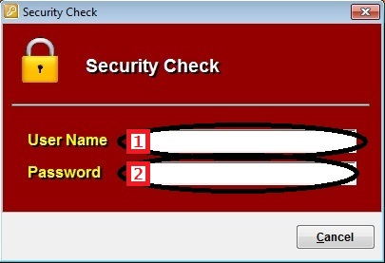

**Stock Withdrawal Advice**

1. To enter stock withdrawal advice form, from the main menu click on STOCK WITHDRAWAL ADVICE > STOCK WITHDRAWAL ADVICE.

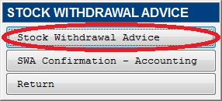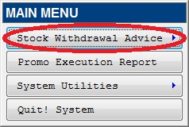

1. To open an existing SWA form, click OPEN button.

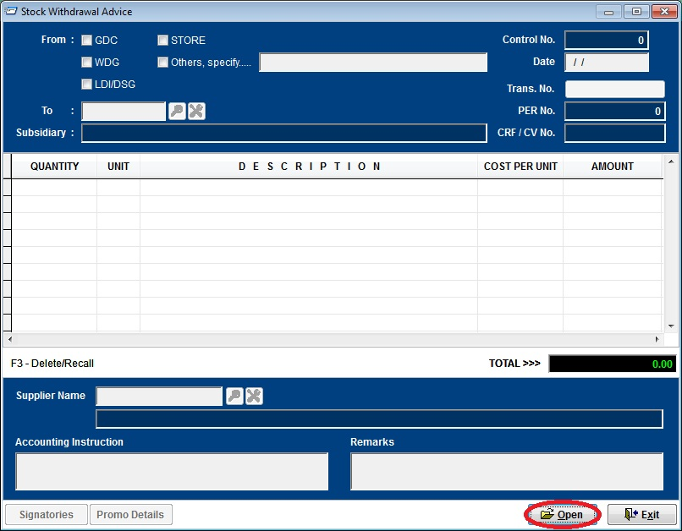

1. Select previous SWA entries. Then click the CHECK button to select.

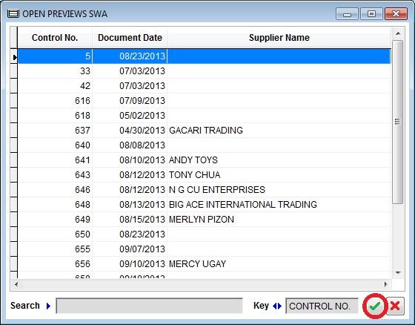

1. To open promo execution report, from the main menu click on PROMO EXECUTION REPORT.

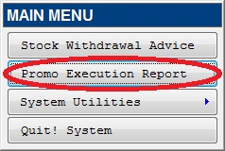

1. To open an existing PER form, click OPEN button.

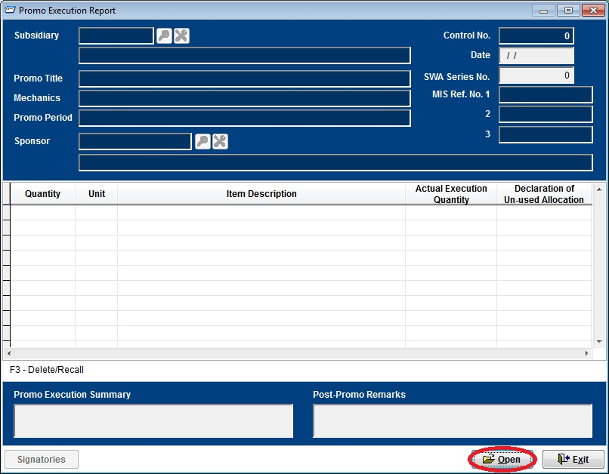

1. Select previous PER entries. Then click the CHECK button to select.

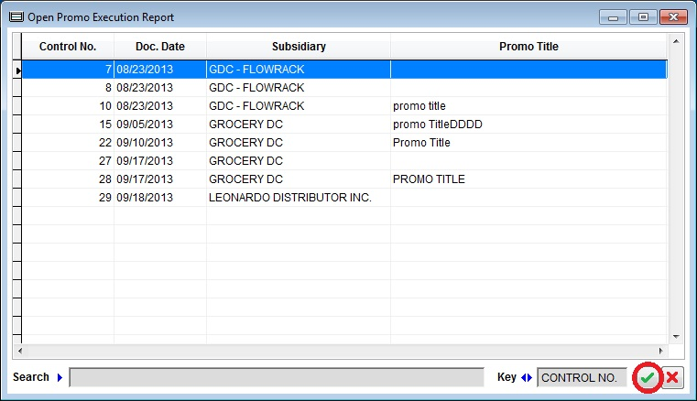

1. After the SWA form has been created and approved. Using the accounting transaction number in the Navision/Designex systems to confirm the SWA. From the main menu go to STOCK WITHDRAWAL ADVICE > SWA CONFIRMATION – ACCOUNTING.

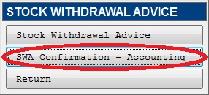

1. Locate the SWA using the control number as a guide, then press enter key to enter the accounting transaction number.

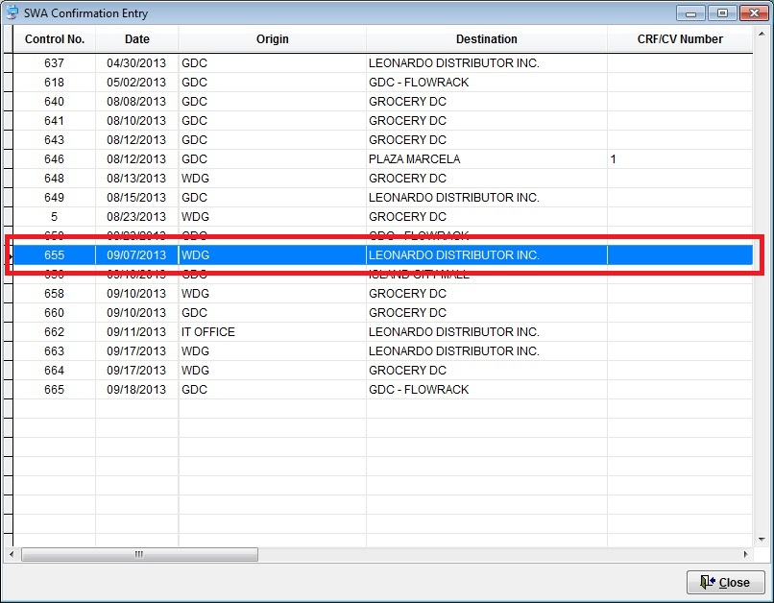

1. Type the CRF/CV transaction number using the Navision / Designex transaction number.

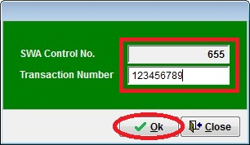

**System Utilities**

1. To change the wallpaper, from the main menu select SYSTEM UTILITIES > SYSTEM WALLPAPER.

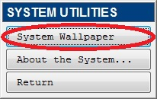

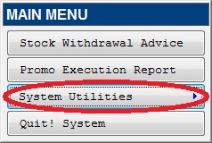

1. Click BROWSE button to select a picture you want to be the wallpaper in your screen.

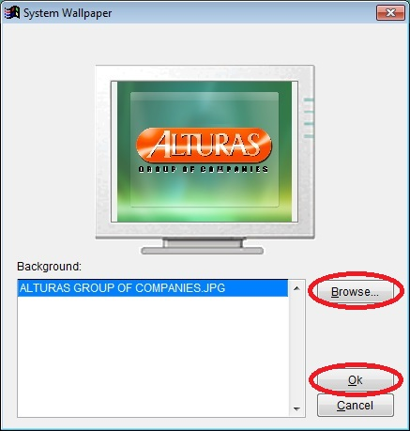

1. Then click OK button to accept picture.

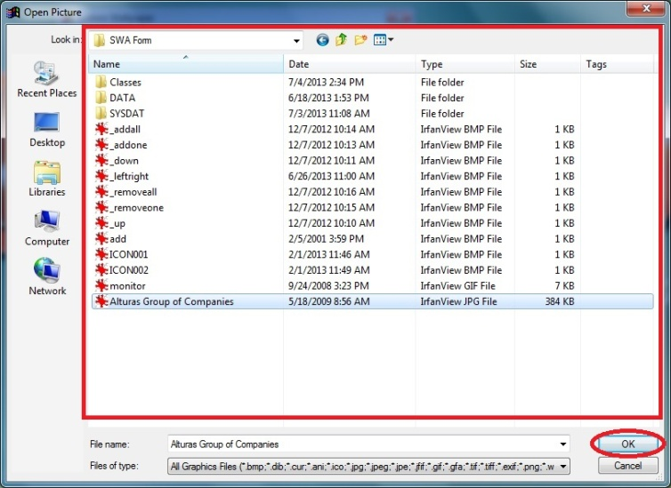

1. Then press OK again in the Wallpaper window to apply the picture as the system wallpaper.
2. To view the system information, from the main menu select SYSTEM UTILITIES > ABOUT THE SYSTEM....

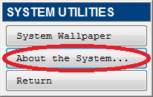

1. About the stock withdrawal advice monitoring system.

